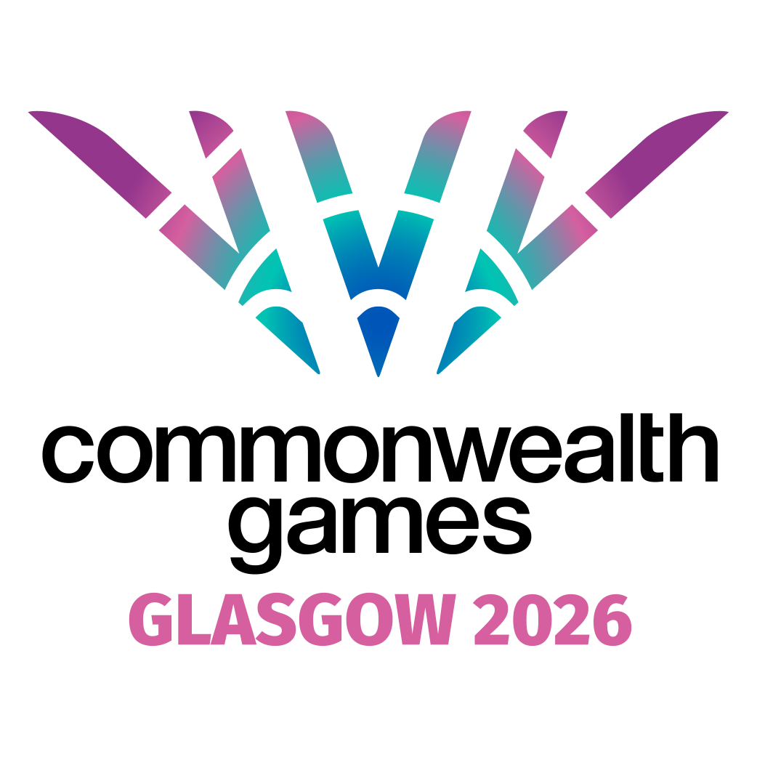

Executive Assistant to the Chief Marketing Officer

|  |  |
| --- | --- |
| **Division:** | Executive Office |
| **Reports to:** | Director of Executive Office & Social Impact |
| **Location:** | Glasgow |

**JOB PURPOSE**

Next summer, Glasgow will host the 23rd edition of Commonwealth Games. Approximately 3,000 athletes and team officials from up to 74 nations and territories across the Commonwealth will come together in a 10-day celebration of sport and culture. Events will take place across Glasgow, entertaining around 500,000 ticketed spectators and reaching a global broadcast audience of almost a billion.

The Chief Marketing Officer (CMO) is at the heart of shaping this story — driving the creative vision, global engagement, and brand experiences that will define Glasgow 2026. To deliver at pace and scale, we are seeking an **exceptional Executive Assistant (EA)** who will be much more than a gatekeeper: a trusted right-hand partner who enables positive impact.

This is a fast-paced, high-profile role in which no two days will be the same. As EA, you will maximise the CMO’s capacity to lead effectively across departments, acting as a key connector, problem-solver, and organiser. You’ll bring energy, discretion, and flair - making sure creativity can thrive while ensuring operational excellence behind the scenes.

The Executive Assistant is a pivotal role within the Organising Company, driving the effective leadership of Glasgow 2026 by providing direct support to our Chief Marketing Officer (CMO). As the CMO leads on the creative vision, storytelling, and engagement that will inspire audiences in Glasgow and across the world, the Executive Assistant will play a vital part in keeping this energy moving at pace.

This role goes far beyond diary management and meeting logistics, it’s about enabling creativity to thrive. From preparing high-impact presentations and supporting brand and communications projects, to helping coordinate campaigns and key stakeholder events, the postholder will be right at the centre of the creative engine room. This is a rare opportunity to step into the inner circle of a world-class sporting and cultural event. As EA to the CMO, you’ll help power the creative engine of Glasgow 2026, influencing how the world experiences the Games.

In addition to supporting the CMO, the Executive Assistant will also play a key role across the wider Executive Office, stepping in to provide cover for fellow Executive Assistants and helping to ensure the smooth running of leadership meetings. This is an opportunity to be at the heart of a fast-moving, idea-driven environment, where no two days are the same and where your contribution will directly influence how the world experiences Glasgow 2026.

We welcome applications from a wide range of sectors and from individuals at all stages of their career. Experience gained in the event industry, project support, personal assistant, private office, executive office or senior administration role is preferred. The successful candidate will be self-motivated, and collaborative with a commitment to ensure the Games are delivered to the highest standards.

**KEY RESPONSIBILITIES AND ACCOUNTABILITIES**

**Executive Support**

* Own the CMO’s complex diary, anticipating needs and prioritising competing demands to maximise strategic impact.
* Manage travel logistics with a focussed attention to detail.
* Serve as a trusted communication hub — screening, drafting, and responding to internal and external correspondence with professionalism.
* Provide seamless departmental coordination, ensuring the CMO’s teams are well-supported, and deadlines are tracked.
* Accompany the CMO to high-profile events, launches, and stakeholder engagements, providing on-the-ground support to ensure everything runs seamlessly — and experiencing first-hand the buzz of bringing Glasgow 2026 to life.
* Prioritising engagements and liaising with the Executive Team to ensure the OC is appropriately represented at key meetings and there are no diary conflicts.
* Provide ongoing organisational support to the wider Executive team to increase effectiveness of the wider leadership team.

**Communications Management**

* Act as the first line of communication for the CMO, reviewing and prioritising incoming correspondence across multiple channels, and responding with clarity and discretion.
* Coordinate and prepare draft responses from across the Executive team on complex and sensitive topics, sourcing technical detail from operational teams as required.
* Draft and proofread engaging external communications and key documents to help tell Glasgow’s story.
* Prepare presentation materials for external engagements.

**Project & Departmental Support**

* Assist with coordination of priority marketing projects, tracking progress and ensuring delivery.
* Support cross-organisation initiatives, representing the CMO’s office with confidence and credibility.

D**ocument and File Management**

* Organise, file, and maintain important documents, both digital and physical ensuring all data protection and confidentiality guidelines are followed.
* Review reports, presentations, and other documents for key meetings.
* Ensure confidentiality and manage sensitive information securely and appropriately.

**Meetings and Events**

* Prepare high-quality materials for Board, Committee, and stakeholder meetings.
* Take and track action-driven minutes from key meetings, ensuring accountability.
* Support the planning and execution of workshops, launches, and high-profile CMO-led events ensuring all logistics and preparations are seamlessly executed.
* Ensure meeting rooms and event spaces are properly set up and have all necessary resources, including welfare, technology and virtual meeting tools.

**Stakeholder Management and Internal Communications**

* Build and maintain relationships with key stakeholders on behalf of the executive.
* Consult with other departments or teams to ensure work is completed in a timely manner.
* Lead special projects and initiatives, working with internal teams and external stakeholders to ensure timely execution.
* Function as a liaison between the executive and other members of the organisation.
* Prepare internal communications updates for the team.
* Liaise with external stakeholders, including the Commonwealth Games Federation.
* Research and gain a working knowledge of the 74 Commonwealth Games Associations (CGAs) located across the Commonwealth to build positive relationships.
* Establish strong working relationships with counterparts in key strategic partners, including Glasgow City Council, Scottish Government and UK Government.

**General Support**

* Assist and support the CEO, Chair and Executive Team as required across a wide range of tasks, administrative duties and support functions.
* Assist and support the Directors of the Executive Office with a wide range of tasks and administrative support relating to the CEO office function.
* Contribute to the development of a positive workplace culture, facilitating staff engagement activities that drive the effective and healthy operational of the business.
* Perform a variety of administrative duties as needed.
* Mentor employees who have not previously worked in a multi-stakeholder environment.
* Support the smooth operation and effective function of the OC.

The responsibilities of this role will evolve during the lifespan of the OC and the changing needs of the Games.

**PERSON SPECIFICATION**

**Experience & Skills**

* Proven experience (3+ years) as an EA, ideally supporting a C-suite leader.
* Background in fast-paced organisations; experience in marketing, sport, or major events desirable.
* Exceptional organisational and multitasking ability, balancing competing priorities calmly and effectively.
* Excellent written and verbal communication skills, with a sharp eye for detail.
* Confident across digital tools (Google Suite, Microsoft Office, collaboration platforms)
* Strong interpersonal skills and excellent at relationship building with experience of building a rapport with senior internal and external stakeholders.
* Experience of the provision of support and advice to C-suite, Executive team and Board.
* Advanced proficiency in Microsoft Office Suite (Word, Excel, PowerPoint, Outlook).
* Strong attention to detail with the ability to manage time efficiently.
* Ability to apply a common-sense approach to issues resolution that takes into consideration the objectives of the wider OC and Games Delivery.
* Demonstrable track record of managing relationships.
* A working understanding of LinkedIn (desirable not essential)

**Personal Qualities**

* A natural problem-solver who anticipates needs before they arise.
* Discreet, trustworthy, and professional at all times.
* Collaborative, adaptable, and energised by working at pace.
* Creative, resourceful, resilient and unafraid to bring new ideas to the table.
* Embraces diversity and displays respect and loyalty
* Engages effectively, and is helpful and supportive towards others
* Highly collaborative, taking the time to engage with team members and external partners
* Reliable and committed to success of the team
* Embraces change and is adaptable
* Natural communicator at all levels, approachable and knowledgeable
* Open and transparent but also maintains trust and confidentiality
* Prepared to challenge information and bureaucracy
* Embraces and absorbs new information
* Displays the highest levels of integrity and confidentiality
* Plans ahead and manages time effectively
* Takes accountability and ownership of tasks and problems
* Tenacious and seeks to overcome obstacles and challenges
* Comes up with ideas and shares these with the team
* Professional, polite and approachable manner
* Positive, optimistic outlook and attitude